**Two Trees Talking**

At the edge of a forest, where a cliff overlooks an ocean, a couple tall trees were talking in the dark late one night. One said, "May I ask you something?"

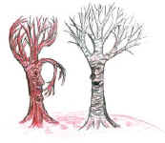"Certainly," said the other.

"I know you all have been all over the world. I, on the other hand... well, I have never been out of this forest. So, my question is, what was it like for you in other places?" The other tree brought in its branches a bit to gather its thoughts. "Well, I'll tell you,” it said.

But it couldn't. Because at that moment, a sudden gust of wind blew. And then another, and another, and suddenly you couldn't see the stars anymore for the clouds racing up.